Impact and Partnerships Manager

Position Description
Employment Type: Part time (0.6 to 0.8 FTE)
Term: [Fixed-term contract] 12 months
Location: Box Hill, Victoria
Reports To: Chief of Staff
Works With: In the Communications team, providing direct support to the whole organisation and external stakeholders including Donors and Funders (government, corporate, philanthropic and private).
Purpose: To support the delivery of Summer Foundation’s strategy by identifying and progressing opportunities to gain support for our work. Managing partnerships with those who do support our work, and measuring the impact of our work.
Responsibilities & Duties
- Monitor and regularly report against our impact measurement targets
- Work closely with all teams in the organisation to understand the nature and priority of funding gaps and proactively plan to fill these gaps
- Proactively identify and respond to funding and support opportunities which align with our strategic plan via Philanthropic, Government, Corporate and Donor channels
- Maintain communication with funding partners and those who support our work, ensuring project outcomes are achieved and the organisation is compliant with the governance associated with funding
- Execute compliance in relation to funding awarded to the Summer Foundation
- Maintain records in a database, including tracking and reporting requirements, working closely with the finance team and project leaders
- Manage a small team, currently one part time Project Relations Officer
Skills & Experience
Qualifications
- Tertiary qualification in a business/arts discipline
- Employment subject to National Police History Check
Experience
- At least 2 years previous experience in a similar role
- Strong knowledge of the not-for-profit sector

Skills
- Ability to proactively and successfully manage partnerships and relationships with Philanthropic, Government, Corporate and Donor stakeholders
- Ability to develop successful grant submissions and partnership proposals
- Ability to work collaboratively with all teams across the organisation to proactively fill identified funding gaps
- Excellent verbal and written communication skills
- Ability to manage multiple tasks and projects concurrently

Core Competencies
The successful applicant’s values will match those of the Summer Foundation. The Summer Foundation’s values include:
- Vision: We are creative, innovative and resourceful. We continually strive to be the best
- Integrity: We act with integrity and honesty in everything we do
- Communication: We communicate openly by exchanging information and actively listening to all stakeholders
- Team Spirit: We value and recognize the contribution of our colleagues, both locally and globally. We enjoy working together to achieve outstanding results and total job satisfaction
- Corporate Responsibility: We act responsibly within our community and care for the environment
Other Relevant Information
The position description is indicative of the initial expectation of the role and subject to changes to Summer Foundation goals and priorities, activities or focus of the job.
People with disability are encouraged to apply. Lived experience is valued by the organisation and looked upon favourably.
We offer
- Salary Packaging
- Flexible working hours
- Supportive and collaborative team environment
- Stimulating and modern office facilities

About the Summer Foundation
Established in 2006, the key aim of the Summer Foundation is to change human service policy and practice related to young people in nursing homes. The Summer Foundation utilises a range of strategies to influence health, housing, aged care and disability service policy and practice related to this target group.
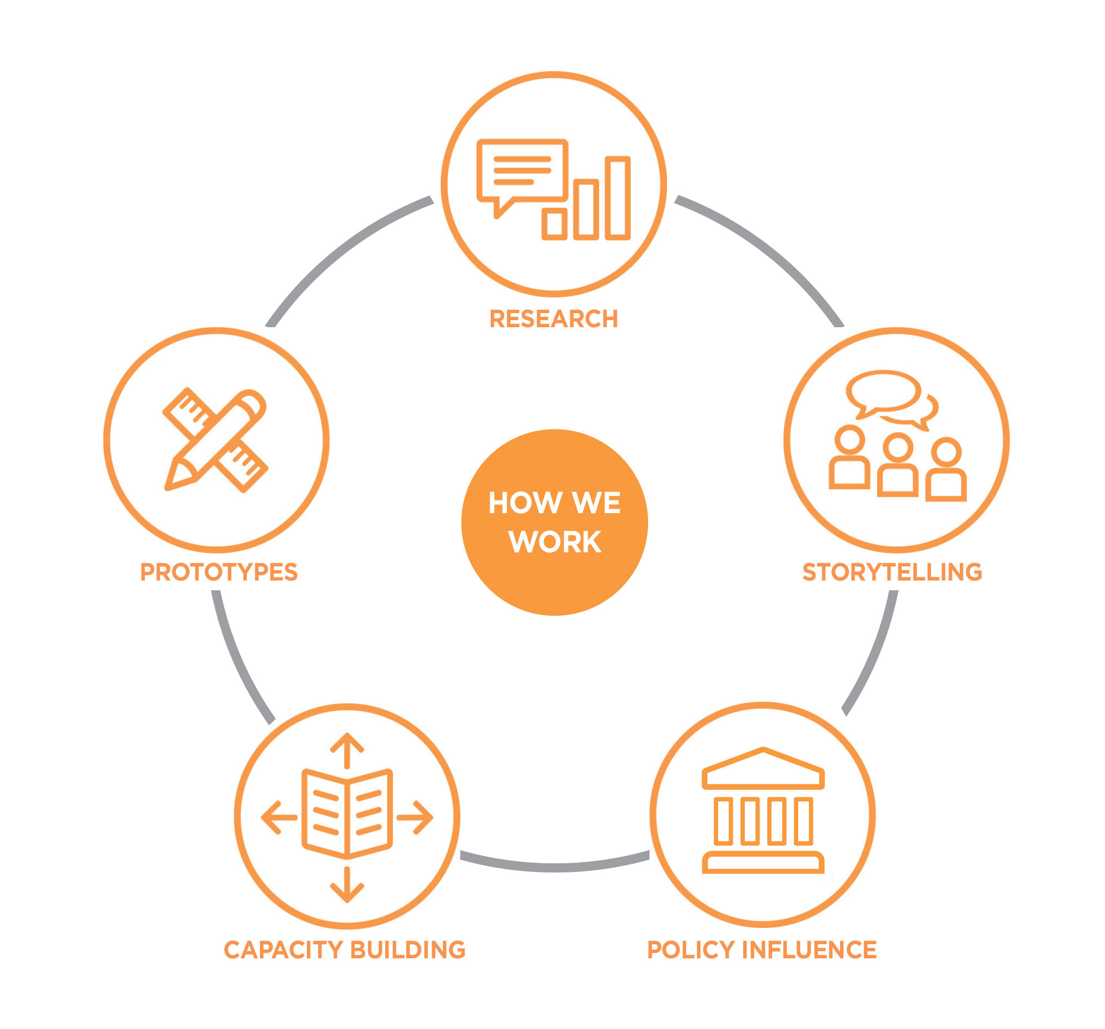
The Summer Foundation’s five key strategies to preventing young people being forced to live in nursing homes are:

Research – Data collection and analysis to provide an evidence base for problem solving
Storytelling – Support people with lived experience to share their journeys and perspectives
Prototypes – Designing, testing and evaluating new solutions
Capacity Building – Share information and best practice with stakeholders
Policy Influence – Shape thinking and change decisions of governments

What policy change do we want?
There are four key areas that must be addressed to resolve the issue of young people in nursing homes in Australia.
- Those in RAC or at risk of RAC entry have NDIS plans which support and reflect their goals
- Significantly increase the volume and range of high quality, accessible and affordable housing
- Health, disability and other systems communicating and collaborating to support discharge to community living
- Define the challenges and explore solutions to barriers that limit access to primary and community health services

