Content Editor | Position Description
Employment Type: Part Time (0.6 FTE)
Term: Fixed Term until 30 June 2019
Location: Box Hill
Reports to: Communications Manager
Works with: Communications Team
Purpose: Enhance the quality and relevance of content, with an emphasis on written content for reports, publications and other printed materials

About the Summer Foundation
Established in 2006, the key aim of the Summer Foundation is to change human service policy and practice related to young people in nursing homes. The Summer Foundation utilises a range of strategies to influence health, housing, aged care and disability service policy and practice related to this target group.
The Summer Foundation’s four key strategies are:
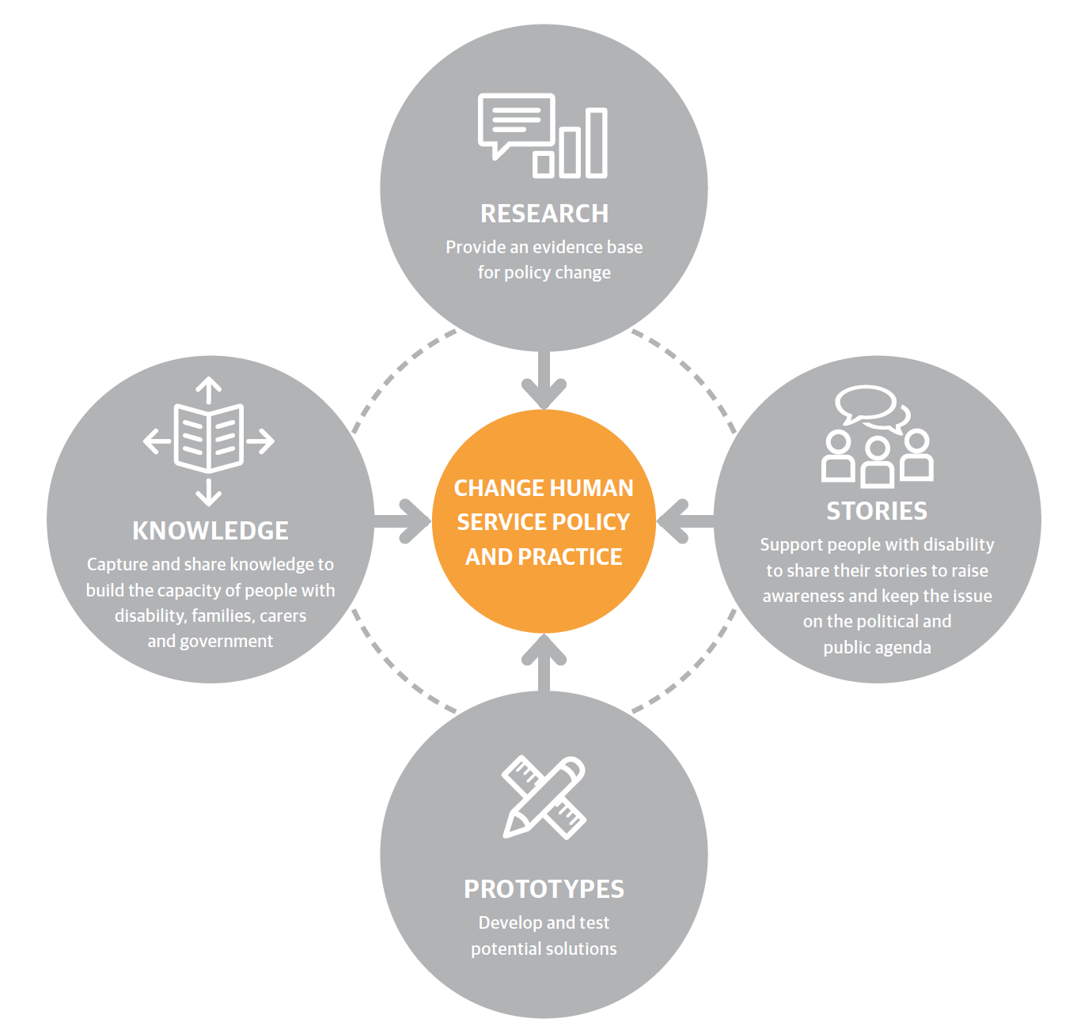
Research – Our research underpins our work and provides an evidence base for policy and practice change.
Stories – Enabling young people with disability and their families to tell their stories and disseminating these stories is a powerful and effective tool for influencing the general public and decision makers.
Prototypes – We design and pilot potential solutions and then evaluate them through action research. This is an iterative process that involves: designing, building, evaluating and learning.
Knowledge – We capture, document and disseminate the knowledge generated from our research and prototypes, in order to encourage others to replicate and scale
our work.

What policy change do we want?
There are four key areas that must be addressed to resolve the issue of young people in nursing homes in Australia:
- Ensure that young people in nursing homes (or at risk of entering one) have effective NDIS plans
- Increase the range and scale of accessible housing and ensure that young people with disability are finding their way into these housing options
- Improve the interface between the NDIS, health and aged care gateways to prevent young people being discharged from hospitals into nursing homes
- Increase access to proactive health services that sustain community living for young people with disability
Position Summary
The Summer Foundation produce an extensive range of reports, publications, resources for people with disability and other materials, both written and web based.
This position exists to ensure that all content produced by the Summer Foundation is well written, has been edited and is in an appropriate format for the intended application and audience.
The position is three days per week until 30 June 2019. This position will work closely with the Internal Services Co-ordinator, who will oversee the production of materials, and the Communications Manager, who will focus on the strategic value of Summer Foundation communications.

Key Accountabilities
- Copywriting: Prepare copy as required for Summer Foundation publications and online communications, based on source materials provided by the Summer Foundation’s Storytelling, Practice and Policy teams. In addition, provide copywriting support to our sister organisation, Summer Housing, as required.
- Editing: Review the content and format of written material drafted by the Summer Foundation’s Storytelling, Practice, and Policy teams. Also review the content and structure of material drafted by our sister organisation, Summer Housing
- Social media: Prepare and upload social media content as outlined in our communications plan

Core Competencies
The successful applicant’s values will match those of the Summer Foundation. The Summer Foundation’s values include:
Vision: We are creative, innovative and resourceful. We continually strive to be the best
Integrity: We act with integrity and honesty in everything we do
Communication: We communicate openly by exchanging information and actively listening to all stakeholders
Team Spirit: We value and recognize the contribution of our colleagues, both locally and globally. We enjoy working together to achieve outstanding results and job satisfaction
Corporate Responsibility: We act responsibly within our community and care for the environment

Work related Competencies
Copywriting: Able to take content from its raw form and put it together in an engaging and succinct written format
Editing: Ability to edit and structure content to maximise impact, giving consideration to audience, purpose and method of communication
Spelling and Grammar: Impeccable attention to detail in relation to house style, expression, spelling and grammar

Skills and Experience
- Demonstrated editing skill
- Demonstrated copywriting skill
- Strong organisational and time management skills and excellent attention to detail
- Confident and competent user of technology (e.g. smart phone; laptop computer)
- Experience using a social media scheduling tool, such as Hootsuite or Buffer, would be an advantage, as would experience using a web CMS such as WordPress
- Current police check
- Team player who contributes to total team success

Other Relevant Information
The position description is indicative of the initial expectation of the role and subject to changes to Summer Foundation goals and priorities, activities or focus of the job.

