Communications Officer | Position Description
Employment Type: Full Time
Term: 12 months
Location: Box Hill, Victoria
Reports to: Chief of Staff
Works with: Summer Foundation staff, young people with disability (including Summer Foundation Ambassadors), family members, and media, external parties such as service providers, editors, photographers, cameramen etc.
Purpose: To raise community awareness of the issue of Young People in Nursing Homes, and to generate support for the key messages and strategic priorities of the Summer Foundation.

About the Summer Foundation
Established in 2006, the key aim of the Summer Foundation is to change human service policy and practice related to young people in nursing homes. The Summer Foundation utilises a range of strategies to influence health, housing, aged care and disability service policy and practice related to this target group.
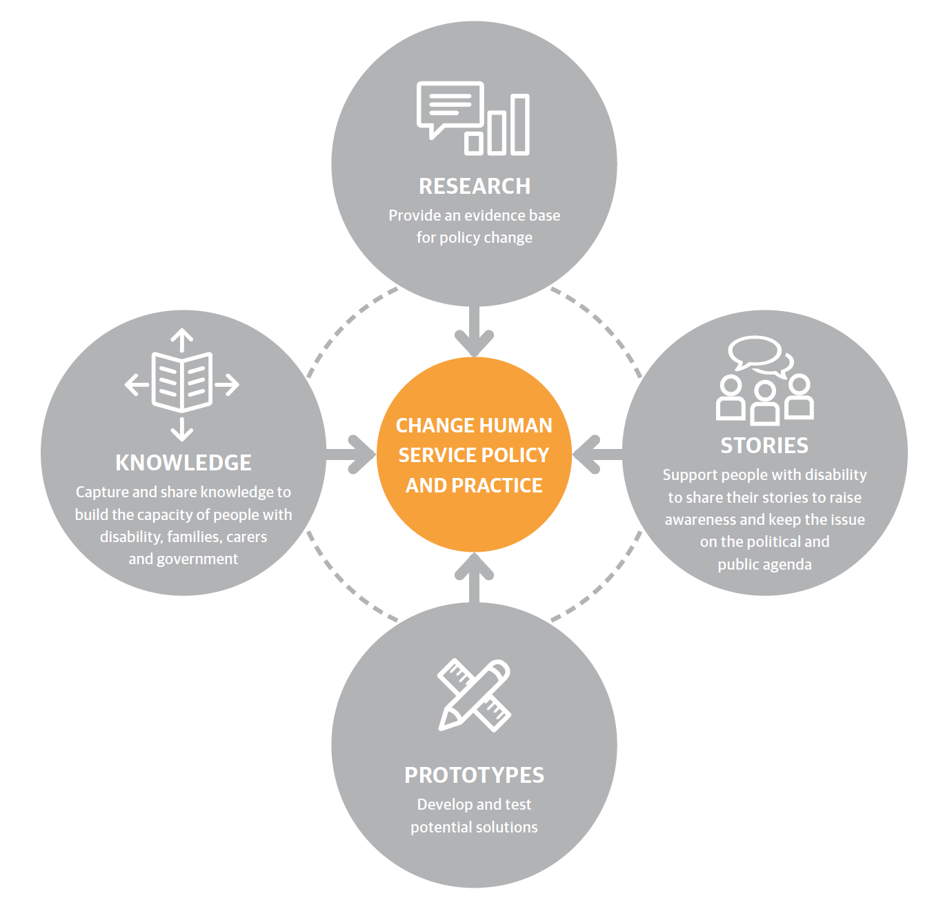
The Summer Foundation’s four key strategies to preventing young people being forced to live in nursing homes are:
Research ~ Our research underpins our work and provides an evidence base for policy and practice change.
Stories ~ Enabling young people with disability and their families to tell their stories and disseminating these stories is a powerful and effective tool for influencing the general public, decision makers and politicians.
Prototypes ~ We design and pilot potential solutions and then evaluate them through action research. This is an iterative process which involves: designing, building, evaluation and learning.
Knowledge ~ We capture, document and disseminate the knowledge generated from our research and prototypes in order to encourage others to replicate and scale our work

About the Position
The Communications Officer position is a “hands on” role, which focuses on external communications. The role will manage social media and online platforms along with editing & developing written communication. Content development will be both for written and video formats.

Responsibilities & Duties
- Develop and manage content and strategy for all social media channels including monthly analytics
- Advanced copy writing for a variety of communications materials such as reports (including the Summer Foundation annual report), brochures, re-purposing philanthropic submissions, email marketing, flyers and newsletters
- Advanced editing for a variety of communications materials
- Proactively undertake media monitoring and scanning of relevant sources of news, information updates and ideas relevant to our work.
- Includes sourcing and filing copies of all media articles and clips Summer Foundation is involved in generating with permission to distribute through Summer Foundation communication channels
- Developing written media pitches and releases
- Responsible for consistent brand representation and management
- Basic video editing skills
- Event co-ordination (for events across the organization)

Skills and Experience

Essential
- Relevant tertiary qualifications in Marketing, PR or Communications
- Minimum of 5 years work experience in a PR/communications capacity
- Recent experience working within the disability sector
- Confident and competent user of technology (including video editing software, Wordpress, MailChimp and various social media channels and management platforms such as Buffer and Hootsuite)
- Strong communication skills & presentation
- Advanced writing and editing skills
- Able to work within a team effectively as well as autonomously and produce content of a high standard.
- Able to work efficiently with strict deadlines
- Strong organisational and time management skills
- Demonstrated relationship management experience
- Demonstrated brand management experience
- Current police check

Desirable
- Experience working with people with disability
- Involvement or experience with the issue of young people in nursing homes

Key Values and Competencies
- Complex problem solving skills
- Develops and maintains effective networks with internal and external stakeholders
- Passionate about making an impact in relation to improving the lives of people with disability and their families
- Embodies integrity, professionalism and dedication
- Commits to growing a movement that will resolve the issue of young people in nursing homes
- Supports, informs and empowers people with disabilities and their families is key to resolving the issue
- Preserves our credibility is paramount; we are committed to integrity in our relationship with others and the preservation of facts
- Shares credit and power with the organisation and other organisations
- Collaborates with other non-profits to increase funding for the disability sector rather than compete for scarce resources
- Shares knowledge, skills and leadership with other organisations.

Other Relevant Information
- The position description is indicative of the initial expectation of the role and subject to changes to Summer Foundation goals and priorities, activities or focus of the job.
- The Summer Foundation encourages applications from people with disability.

Application Process
Please submit your written application together with your resume no later than 5pm 30th March 2017 to:
Natasha Hendricks
Executive Assistant to Chief of Staff
natasha.hendricks@summerfoundation.org.au

