NDIS Housing Market Facilitator | Position Description
Purpose
To take charge of the Summer Foundaiton’s program of work helping to build the capacity and confident of housing providers, banks and people with disability to develop and access housing in the NDIS. The role will work with a high degree of autonomy to write papers, undertake research and analysis, engage consultants and design practical initiatives across five housing projects. The candidate will bring a high degree of existing housing expertise and a practical approach to problem solving.

Position Summary
The NDIS Housing Market Facilitator will be responsible for leading the Summer Foundation’s work to move NIDS housing from an early stage market towards a mature market. The role will work with housing providers (Community Housing Providers and private developers), banks and financial institutions as well as people with dibsaility and service providers across Australia.
The role will take responsibility for delivering the following project, with assistance from consultants as required:
- Designing a platform to identify NDIS participants who require housing and connecting with NDIS housing providers;
- Building an online resource bank of housing information for people with disability
- Developing a guide for housing and service providers on how to separate the provision of housing from the provision of support
- Undertaking a national Housing Demand Study to quantitatively document the demand for accessible housing in the NDIS by state, and qualitative needs and preferences of people with disability for their housing in the NDIS;
- Development of a shared equity and home ownership product with financial institutions to enable people with disability to enter home ownership.
You will need to display a ‘can-do’ attitude and actively contribute to developing a culture of excellence, creativity, responsiveness and flexibility. Expertise in housing, excellent communication, negotiation and influencing skills are a must.

Experience
- You will have at least 3-5 years experience as an applied researcher, senior policy adviser or service manager;
- You will have a very advanced level of understanding about housing, and ideally also some level of understanding about the NDIS;
- You will have experience delivering practical projects and initiatives;
- You will have excellent written communication skills, and an ability to communicate to a variety of audiences and develop a range of written product types.

Employment Type: Full Time (Part Time negotiable)
Term: 4-12 month contract
Location: Based in Victoria. Box Hill, Melbourne preferred.
Reports to: Strategic Projects Manager
Works with: Head of Policy & Strategy, Partner Organisations, Government

About the Summer Foundation
Established in 2006, the key aim of the Summer Foundation is to change human service policy and practice related to young people in nursing homes. The Summer Foundation utilises a range of strategies to influence health, housing, aged care and disability service policy and practice related to this target group.
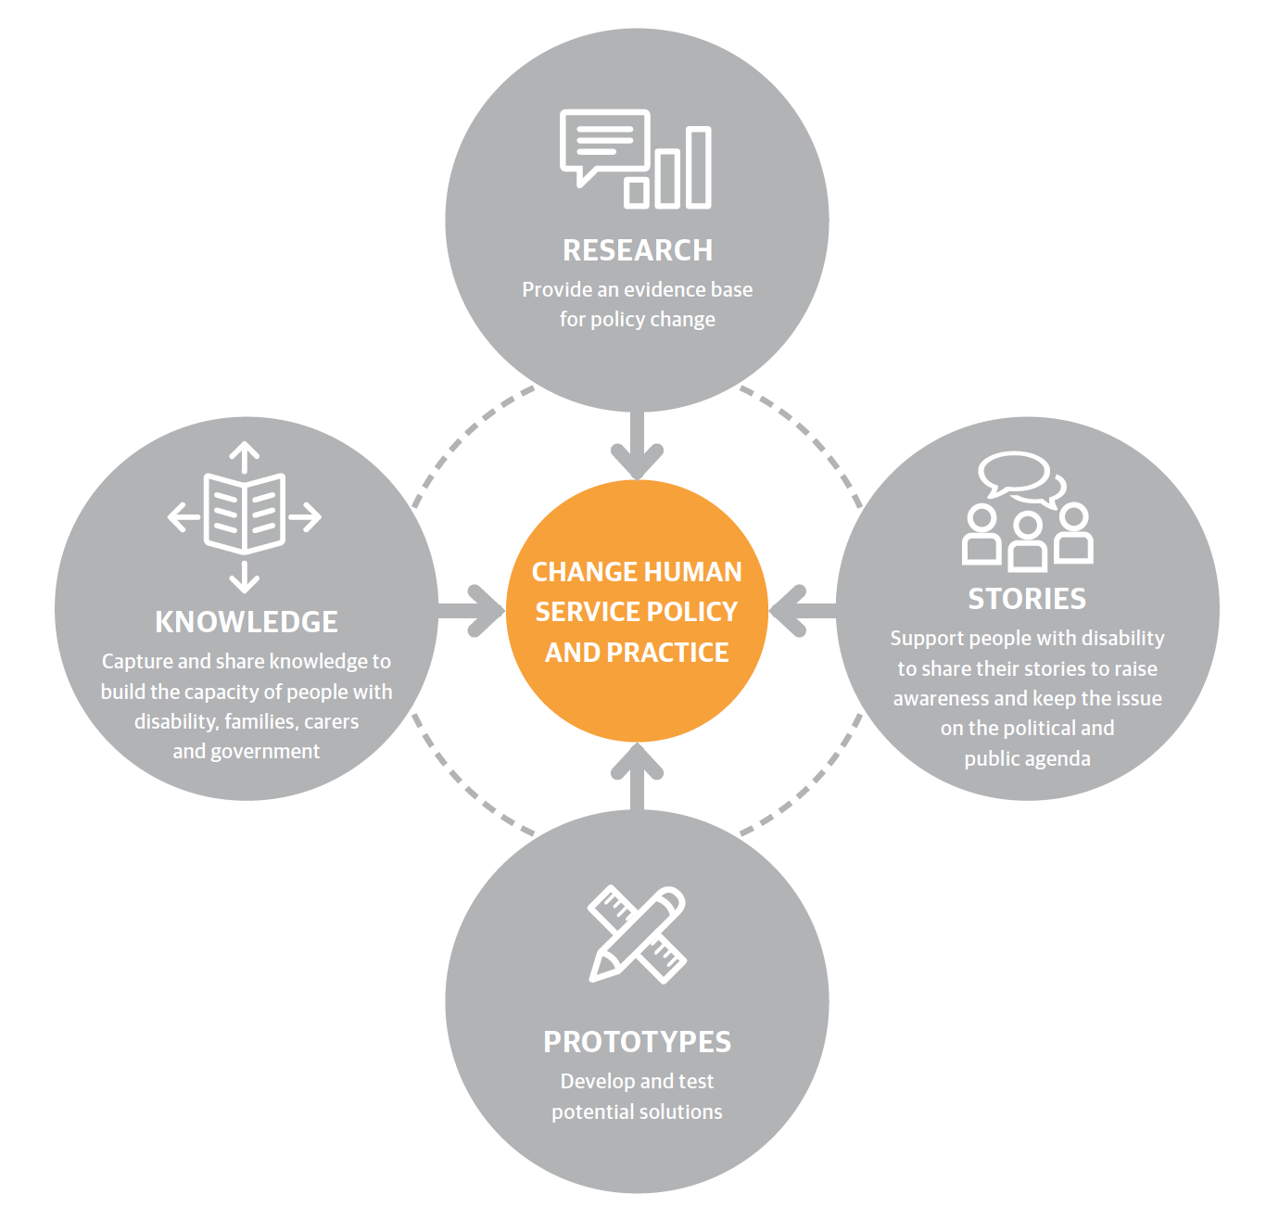
The Summer Foundation’s four key strategies to preventing young people being forced to live in nursing homes are:
Research ~ Our research underpins our work and provides an evidence base for policy and practice change.
Stories ~ Enabling young people with disability and their families to tell their stories and disseminating these stories is a powerful and effective tool for influencing the general public, decision makers and politicians.
Prototypes ~ We design and pilot potential solutions and then evaluate them through action research. This is an iterative process which involves: designing, building, evaluation and learning.
Knowledge ~ We capture, document and disseminate the knowledge generated from our research and prototypes in order to encourage others to replicate and scale our work.

What policy change do we want?
There are four key areas that must be addressed to resolve the issue of young people in nursing homes in Australia.
- Ensure that young people in residential aged care get access to the National Disability Insurance Scheme (NDIS)
- Prevent new admissions to residential aged care facilities
- Increase the range and scale of housing
- Developing and maintaining a model of support that treats people with disability with dignity and respect, and fosters independence and community inclusion.

